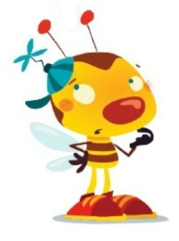

**KAJ MANJKA?**

|  |  |  |  |  |
| --- | --- | --- | --- | --- |
| http://static.wishuponahero.com/wishes/2012/11/27/6b261aedaec7b7cfd6c462676905bfd2.gif |  | http://static.freepik.com/free-photo/piano-clip-art_435730.jpg |  | http://www.birdville.k12.tx.us/el_lessons/5th_Six_Weeks/3rd/Math/CPS%20MATH%20TAKS%20PRACTICE_1/Pre_Post%20Test%20and%20Objective%20Lessons/CPS_Databases/Image%20Library/Clip%20art%20library/Things/House/Outdoor%20Living/bench.jpg |
| __ __T__ |  | KL__ __ __ R |  | KL__P |
|  |  |  |  |  |
| http://thumbs.dreamstime.com/z/sun-clip-art-cartoon-illustration-cute-character-32926949.jpg |  | http://thumbs.dreamstime.com/z/green-isolated-tree-clipart-2760002.jpg |  | **http://www.clipartbest.com/cliparts/niE/XxB/niEXxBeBT.jpeg** |
| Ž__R__K |  | DR__ __ __ |  | Z__BR__ |
|  |  |  |  |  |
| http://www.clipartbest.com/cliparts/4Tb/4zp/4Tb4zp8Tg.jpeg |  | http://sweetclipart.com/multisite/sweetclipart/files/snail_2_brown_green.png |  | http://img2.wikia.nocookie.net/__cb20100930003858/clubpenguin/images/4/46/GardenShovel.png |
| Z__B |  | P__LŽ |  | L__P__T__ |
|  |  |  |  |  |
| http://sweetclipart.com/multisite/sweetclipart/files/black_top_hat.png |  | http://www.clker.com/cliparts/1/M/H/m/B/Z/envelope-with-white-letter-md.png |  | http://www.christart.com/IMAGES-art9ab/clipart/278/dove-hover.png |
| KL__BUK |  | P__S__ __ |  | G__L__B |

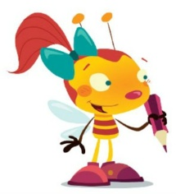

POČASI! PREVIDNO! NATANČNO!

NE POZABI NAME! MED VSAKO BESEDO STOJIM JAZ!

**PIŠEMO**

TOMI IMA NOV AVTO.

|  |
| --- |
|  |
|  |
|  |
|  |
|  |
| TONE IMA NOJA. |
|  |
|  |
|  |
|  |
|  |
| ONA JE TANJA. |
|  |
|  |
|  |
|  |
|  |
| NINO IMA NOTE. |
|  |
|  |
|  |
|  |
|  |
| http://www.clipartpal.com/_thumbs/pd/education/backpack_04.png  TIA IMA NOVO . |
|  |
|  |
|  |
|  |
|  |