8. G 10.teden

Something more about Africa

1. What can you say about these two pictures? (10 sentences)

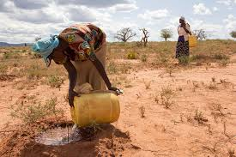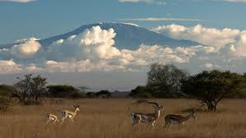

2. Na Youtubu poslušajte pesem Africa (Toto). Ob poslušanju vstavite v besedilo besede, ki manjkajo:

https://www.youtube.com/watch?v=FTQbiNvZqaY

Africa by Toto

I hear the _________________ echoing tonight
But she hears only whispers of some quiet conversation
She's coming in, 12:30 flight
The moonlit wings reflect ____________________ that guide me towards salvation
I stopped an old man along the way
Hoping to find some old forgotten words or ancient _____________________
He turned to me as if to say, "Hurry boy, it's waiting there for you"
It's gonna take a lot to drag me away from you
There's nothing that a ___________________ men or more could ever do
I bless the rains down in Africa
Gonna take some time to do the things we never had (ooh, ooh)
The wild dogs cry out in the night
As they grow ___________________, longing for some solitary company
I know that I must do what's right
As sure as _________________ rises like Olympus above the Serengeti
I seek to cure what's deep inside, frightened of this thing that I've become
It's gonna take a lot to drag me away from you
There's nothing that a __________________ men or more could ever do
I bless the rains down in Africa
Gonna take some time to do the things we never had (ooh, ooh)

Hurry boy, she's waiting there for you
It's gonna take a lot to drag me away from you
There's nothing that a ______________________ men or more could ever do
I bless the rains down in Africa (6x)
Gonna take some time to do the things we never had (ooh, ooh

- Če ste pravilno rešili, preverite v posnetku z (lyrics).

- Translate and explain the following words in English:
echoing - ___________________ drag away - _______________________
to whisper - _____________________ to bless - _______________________
to reflect - ______________________ to long for - ____________________
salvation - _______________________ solitary - ____________________
ancient - ______________________ to seek - ___________________

- Oglejte si še posnetek naše glasbene skupine Perpetuum Jazzile - Africa…

https://www.youtube.com/watch?v=yjbpwlqp5Qw

- ……and answer the following questions:

1. Why does the song begin with the imitation of rain?

2. Find the expressions in the song which label Africa.

3. How does the singer feel about Africa? What will he never do?

3. Izberite eno afriško naravno znamenitost in jo opišite. Opis mi pošljite na vpogled po mailu. Kateri 2 znamenitosti sta že omenjeni v pesmi?

Lep pozdrav.

