6 REVIEW – ponovitev – preizkusi svoje znanje
1. Označite dele telesa.
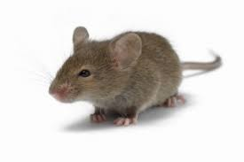
2. Opišite žival na sliki.
3. How many wild animals do you know? Name them.
4. V delovnem zvezku rešite vaje na strani 46 in 48.
xxxxxxxxxxxxxxxxxxxxxxxxxxxxxxxxxxxxxxxxxxxxxxxxxxxxxxxxxxxxxxxxxxxxxxxxxxxxxxxxxxxxxxxxxxxxxxxxxxxxxxxxxx
FOOD AND DRINK
1. Iz učbenika str. 68 izpišite izraze za hrano in pijačo. Razvrstite jih po skupinah in DODAJTE svoje primere (čimveč):
a. MEAT:
b. DAIRY PRODUCTS(mlečni izdelki):
c. FRUIT (vsaj 20):
d. VEGETABLES (vsaj20):
e. BREAKFAST:
f. LUNCH:
g. DRINK:
2. Answer the following questions:
a. What do you usually have for breakfast? If you have it? ___________________________________________
b. What do you have for lunch? ___________________________________________________________________
d. Do you eat anything for dinner? If yes, what do you have? ____________________________________________
e. Which is your favourite fruit / vegetable / drink? ____________________________________________________
3. Rešite vajo 1 iz delovnega zvezka str. 44.

