6. G 8.teden

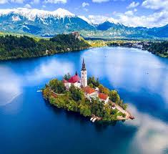
BEAUTIFUL SLOVENIA

1. V učbeniku stran 73 preberite besedilo z omenjenim naslovom.

2. Poiščite pomen naslednjim besedam:
USEFUL SCENERY UNDERGROUND CAVE CRYSTAL CLEAR SEASON BE SURROUNDED
HIKING PASTIME PICK UP CHESTNUTS REGION HARVEST FAMOUS FOR SKI RESORT
INTERNATIONAL COMPETITION SKI JUMPING SIMPLY BORDER
3. Odgovorite na vprašanja – TASK 1, 2 – odgovore zapišite v zvezek.
4. What do you like best about Slovenia?
Which is your favourite area or town?
5. Besede iz naloge 2 vstavite po pomenu:
1. What a beautiful __________________________ with all these mountains, valleys, rivers, …
2. I love skiing. I can’t wait to go to that famous ___________________________.
3. We have 4 _____________________ of the year; spring, summer, …..
4. Our family loves ______________________. Every Sunday we go to a different mountain.
5. Fishing is an enjoyable ______________________ for people of all ages.
6. Na spletu poiščite podatke o eni znamenitosti v Sloveniji in jo opišite (najmanj 10 povedi).
Fotokopijo naloge mi pošljite ma mail.

Lep pozdrav.

