RAMBO RHINO
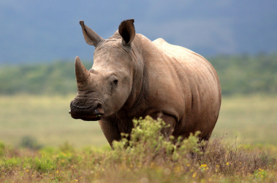
“Hi! It's me, Rambo Rhino – over here to the right. Wait! Don't run away! I may look scary, but I promise I will not cause any trouble. I am a black rhinoceros. I live in Africa. So do my cousins, the white rhinos. OK, are you rhino-ready? My name, rhinoceros, means “nose-horn”.
A rhino is the only mammal that has horns on its nose. Sheep and antelope, for example, have their horns on their heads. If one of my horns breaks off, I can grow a new one in its place. No other animal with horns can do that. When I was five months old, I was just starting to grow my front horn.
My mother is always near me because I’m still a child. Like all black rhino moms, she had just one rhino baby at a time. My mom watches out for danger if a hungry lion or hyena wants to attack me. Now and then I shout loudly. That means, “I’m hungry, Mom!” So she takes a break and lets me drink milk. My mom is teaching me all I need to know to survive until I am three. Then I can go off on my own.
My cousins, the white rhinos, often hang out in groups and eat grass together. I, on the other hand, like to be alone. By the way, both white and black rhinos are grey. Some say I have a bad temper. But it is because I have bad eyes. I can’t tell a tree from a person until I’m very near. So, to be safe, I attack. I can be very fast. I can reach a speed of 56 km an hour – as fast as a horse runs. Better watch out if you are in my way. I can knock over a car or a small truck. I’ve loved telling you all about my favourite subject: me! Hope to run into you again.”
(povzeto po NPZ)
1. Preberi besedilo, izpiši neznane beside in jih prevedi v zvezek:
2. Answer the following questions:
1. Where do black rhinos live? __________________________________________________________________
2. Where does a rhino have its two horns? _________________________________________________________
3. When do rhino's horns start to show? _____________________________________________________________
4. Which animal wants to attack baby rhinos? ___________________________________________________________
5. How old is the rhino when it leaves its mom? ___________________________________________________________
6. What colour are white rhinos? _____________________________________________________________________
7. Why does a rhino attack so quickly? _________________________________________________________________
3. Oblikuj miselni vzorec s ključnimi besedami.

Dodatno- neobvezno: na tej spletni strain si lahko prebereš več zgodb o živalih in rešuješ naloge:
https://worksheetsplus.com/Reading/1stReadingDolphins.html

