6. G 10.teden

Ponovno vas pozivam, da mi naročeno redno pošiljajte na vpogled. Prav tako rešitve teh nalog.
1. LET’S REPEAT:
1. Translate the following expressions:
Danes je sončno. Je mraz in sneži.
Zunaj je vetrovno. Vreme je lepo le včasih malo oblačno.
Dežuje. Jutri je megleno.
2. Spring starts _________________________________________________________
The weather is _______________________________________________________
People usually __________________________________________________________
I feel ___________________________________________________________________
2. AT HOME
1. V zvezek narišite hišo in razporedite sobe v njej ter jih poimenujte (dodajte attic, pantry, cellar, boiler room, roof, chimney, garage, garden, balcony,…)
Pomagajte si z učbenikom stran 80 in 132.
2. Opišite svojo hišo:
I live at ___________________. Our house has got downstairs and upstairs. There are …..
downstairs.
(pazite na pravilno rabo there is / there are… - ednina, množina)
3. The White House building
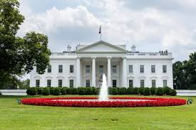
The White House is the official residence and workplace of the president of the United States. It is located at 1600 Pennsylvania Avenue NW in Washington, D.C., and has been the residence of every U.S. president since John Adams in 1800.
There are 132 rooms, 35 bathrooms, and 6 levels in the Residence. There are also 412 doors, 147 windows, 28 fireplaces, 8 staircases, and 3 elevators.

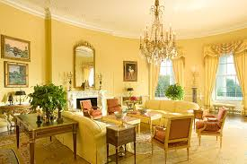
The State Floor of the residence building includes the East Room, Green Room, Blue Room, Red Room, State Dining Room, Family Dining Room, Cross Hall, Entrance Hall, and Grand Staircase. The Ground Floor is made up of the Diplomatic Reception Room, Map Room, China Room, Vermeil Room, Library, the main kitchen, and other offices. The second floor family residence includes the Yellow Oval Room, East and West Sitting Halls, the White House Master Bedroom, President's Dining Room, the Treaty Room, Lincoln Bedroom and Queens' Bedroom, as well as two additional bedrooms, a smaller kitchen, and a private dressing room. The third floor consists of the White House Solarium, Game Room, Linen Room, a Diet Kitchen, and another sitting room.
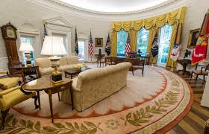
The West Wing houses the president's office (the Oval Office) and offices of his senior staff, with room for about 50 employees. It also includes the Cabinet Room, where the president conducts business meetings and where the Cabinet meets.

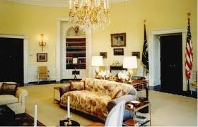
The East Wing, which contains additional office space, was added to the White House in 1942. Among its uses, the East Wing has intermittently housed the offices and staff of the first lady, and the White House Social Office.

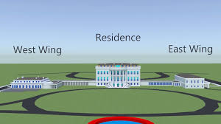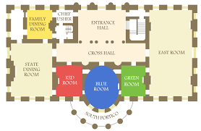

1. Answer the following questions:
1. What’s the White House address? _______________________________________________
2. How many rooms has it got altogether? ____________________________________________
3. Where is the library? __________________________________________________
4. What can one do in the house? _________________________________________________________
5. What’s the president’s office called? ______________________________________________
6. Where does the first lady work? _____________________________________________________
2. What does this mean?
a residence - _____________________ staff - _____________________
a fireplace - ______________________ business meeting - ___________________
an elevator - ______________________ to contain - ______________________
to include - _____________________ among - __________________

